DHIS Setup (Steps 1-3) (DHSI-URC instance)
http://dhis-2.blogspot.com/

Step 4 (PostgreSQL installation only)
https://trac.osgeo.org/postgis/wiki/UsersWikiPostGIS24UbuntuPGSQL10Apt

DHIS Setup (Step 4 Create non-privileged PostgreSQL user)
http://dhis-2.blogspot.com/

DHIS Setup (Step 5 - 8)
http://dhis-2.blogspot.com/

All ports were opened

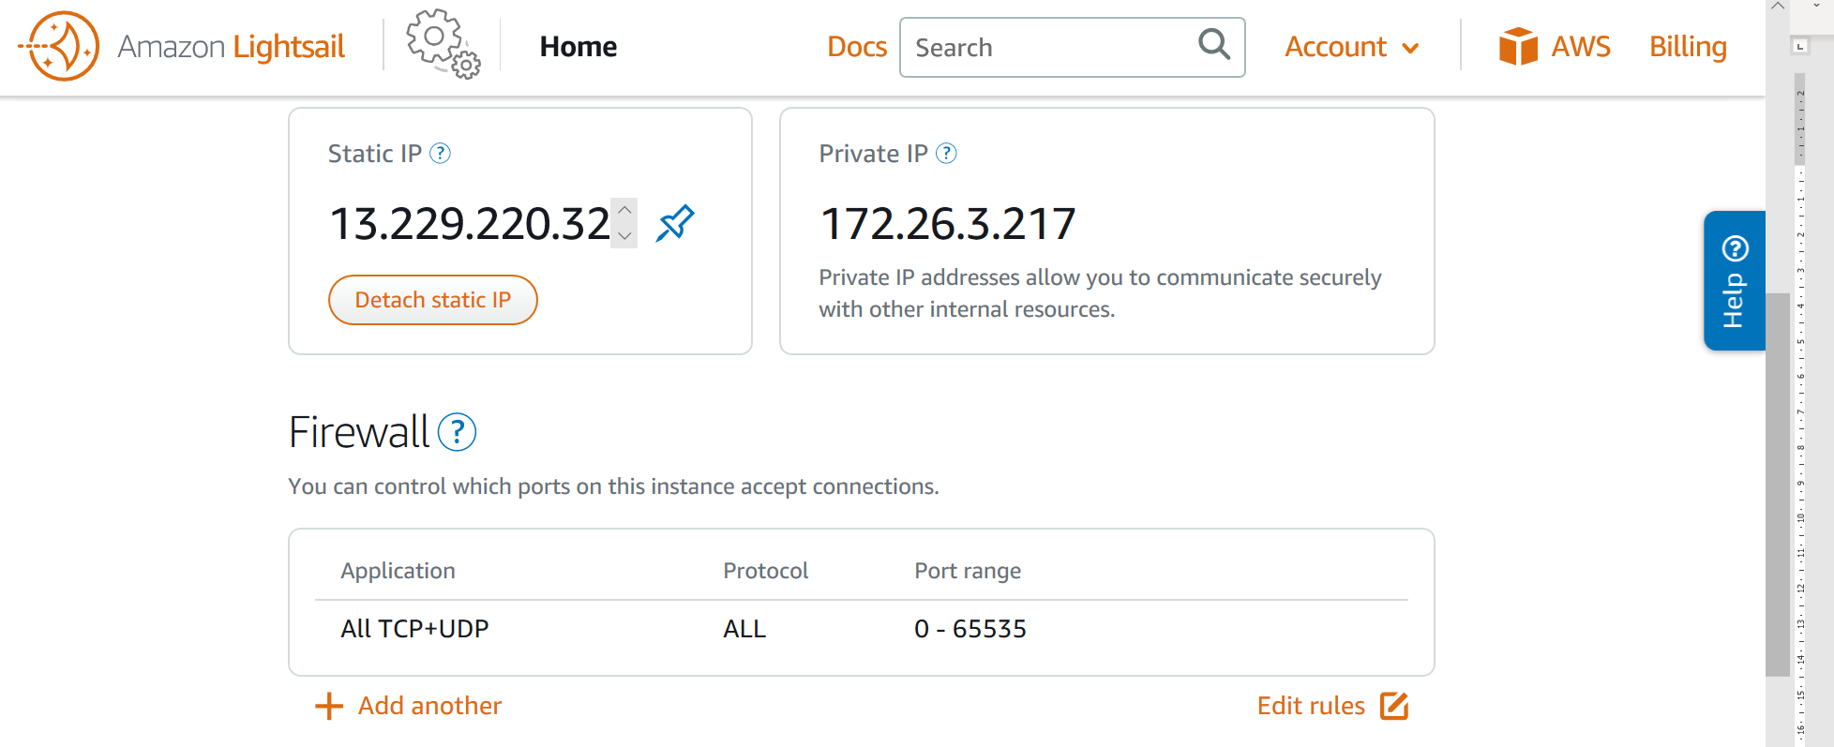

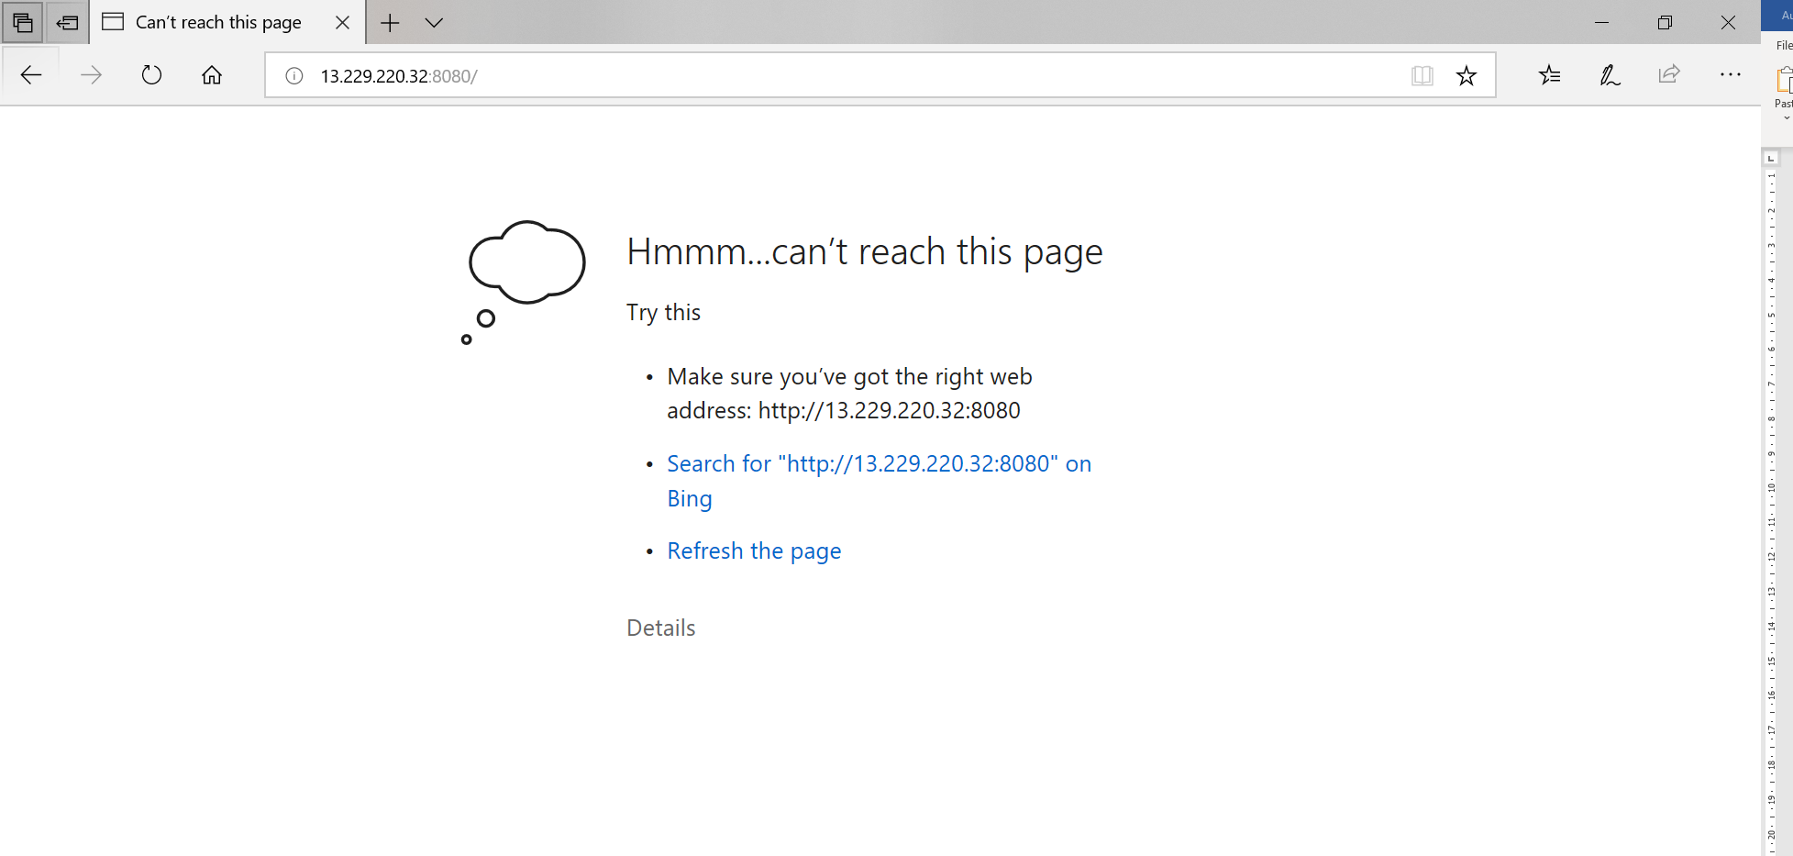

List of running services

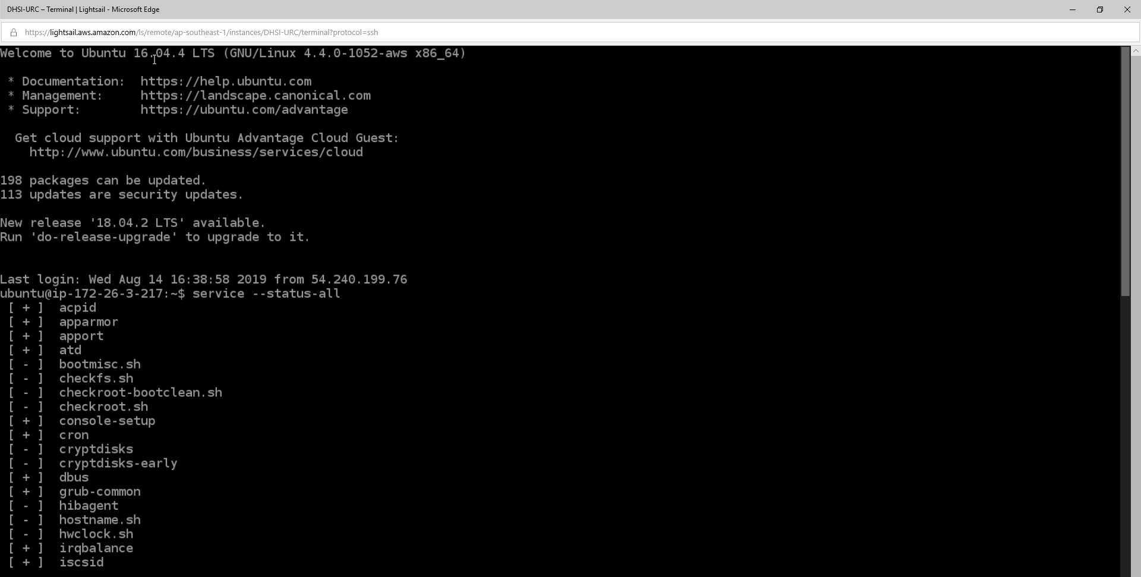

Tomcat started but Status is Dead
